**Inventory Transfer Report**

Module Name - inventory_transfer_report

Branch Name - 18.0-dev

This module allows users to generate reports or Excel files for Transfer In or Transfer Out operations based on multiple filters.

Let’s see how to implement it in Odoo:

1. Go to **Inventory App > Reporting**.
2. In the **Reporting Menu,** users can select the **Inventory Transfer Report** 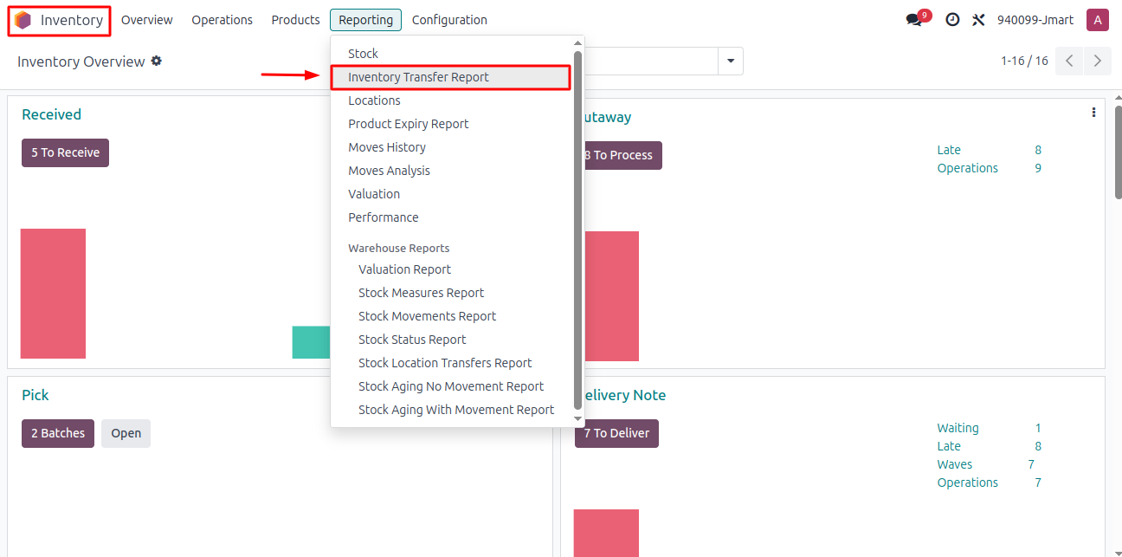menu-item.

***Inventory Transfer Report Wizard***

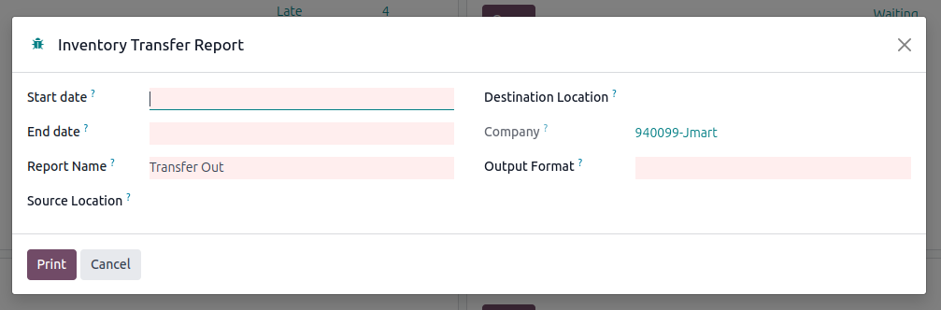

**Wizard Description:**

Upon launching the wizard, users are prompted to apply several filters to generate a customized report:

1. **Date Range (Required):**

**Start Date** and **End Date** fields must be provided.

The system will fetch records that fall within this date range.

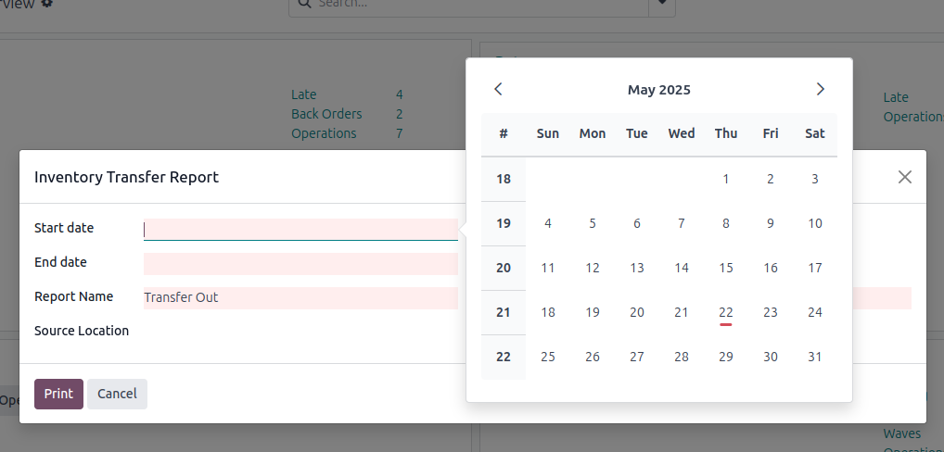

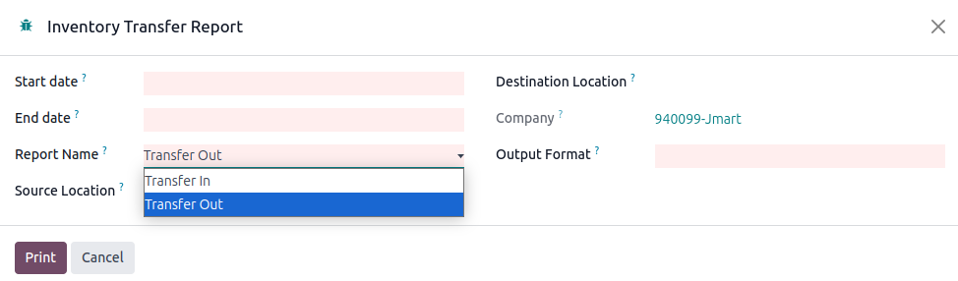

1. **Transfer Type (Required):**

The user must also select the type of transfer—either **Transfer In** (incoming) or **Transfer Out** (outgoing), with **Transfer Out** selected by default.

1. **Source and Destination Locations (Optional):**

The user can optionally select a Source Location or Destination Location. If selected, these will be used as additional filters in the report.

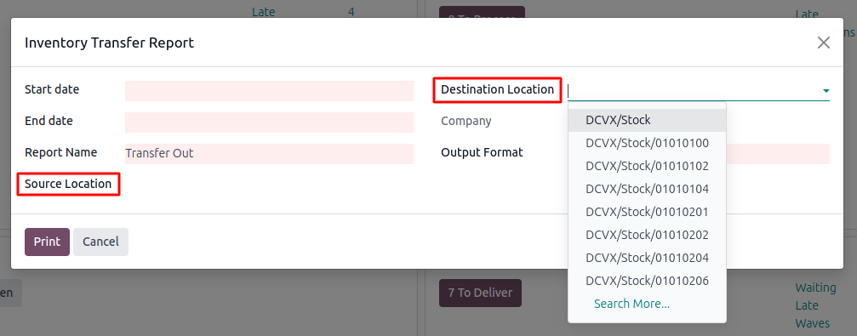

1. 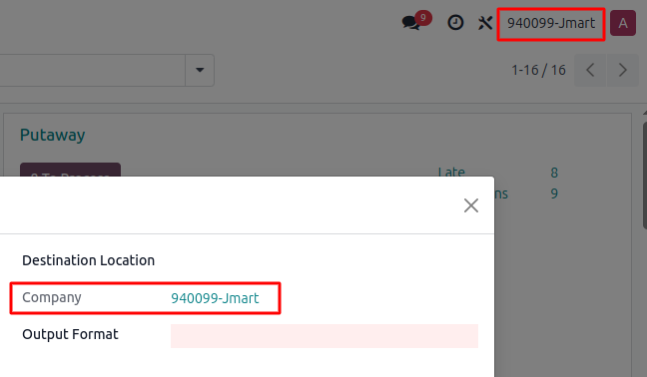**Company (Required):**

The **Company** field is automatically set to the currently selected company by default.

1. 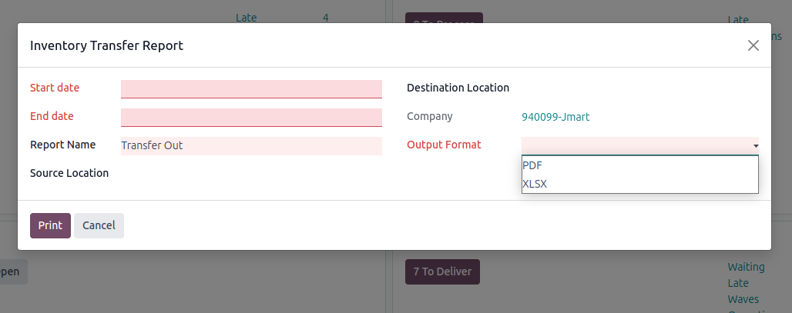**Output Format (Required):**

Finally, users are required to select the **Output Format**, choosing between **PDF** or **Excel**, based on their reporting needs. Once all necessary filters are configured, the system generates the report reflecting the applied criteria.

**For Transfer In Records are filtered :** ( picking_type_code = incoming )

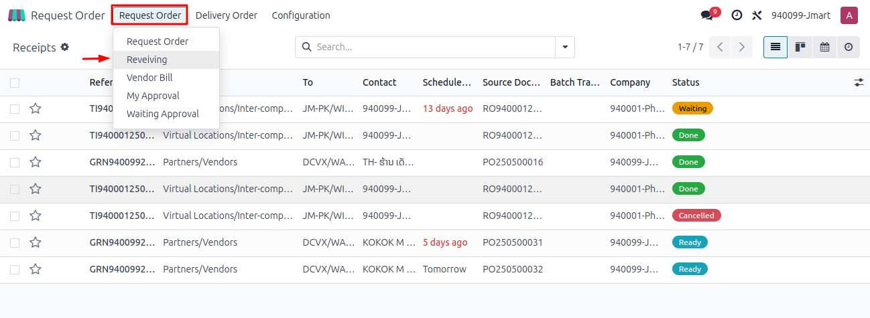

When the **Transfer In** type is selected, the data is fetched from the **Request Order → Receiving** process flow, representing incoming inventory transfers.

**For Transfer Out Records are filtered :** 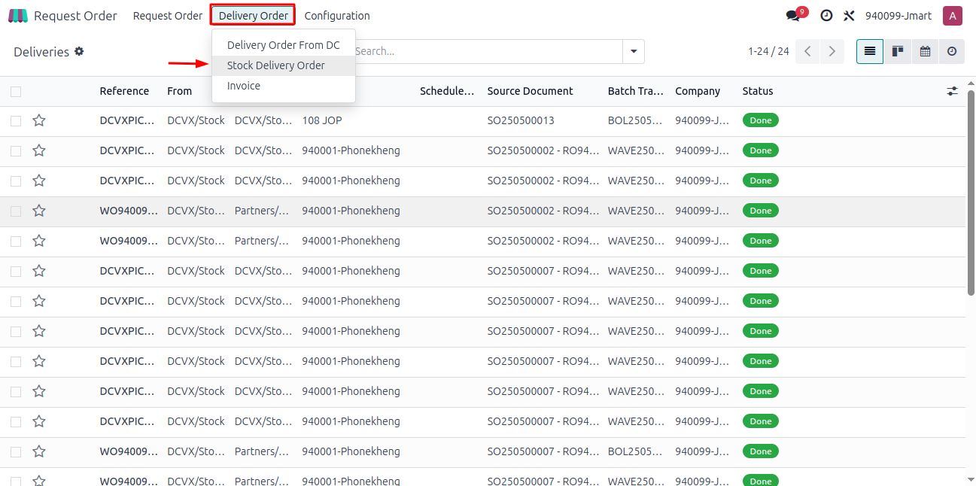( picking_type_code = outgoing)

When the **Transfer Out** type is selected, the data is fetched from the **Delivery Order → Stock Delivery Order** process flow, representing outgoing inventory transfers.

**PDF Report Overview:**

The PDF report provides a well-structured, print-ready summary of filtered data based on user-selected criteria in the wizard. Designed for clarity and readability, the report includes key details such as **Transfer dates, Locations, Transfer type, Transfer no. Quantity, Cost Amount , Total Quantity and Cost.** It is automatically formatted using predefined templates to ensure consistency and professional presentation. This format is ideal for sharing, printing, or archiving purposes, offering a reliable snapshot of the selected inventory transfer records.

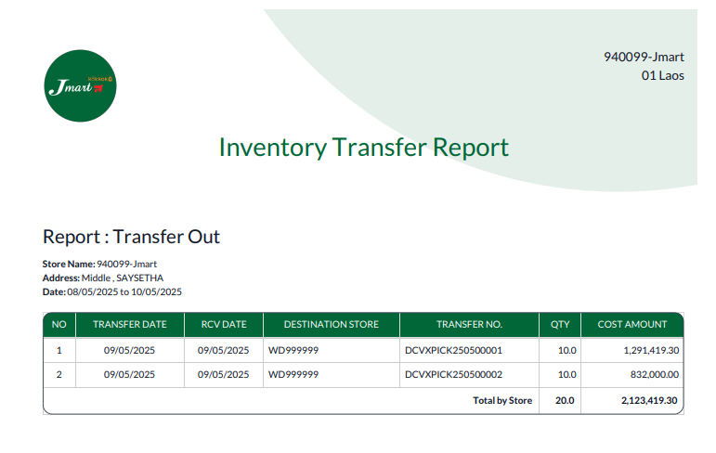 **Transfer Out Pdf :**

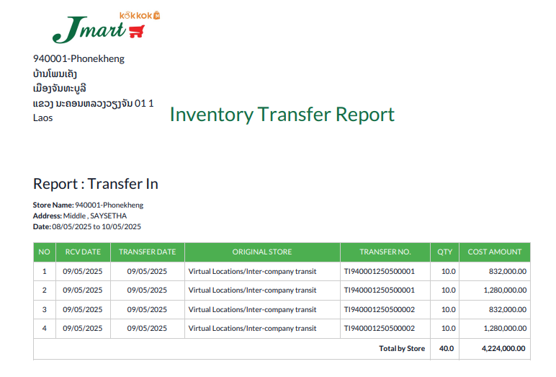 **Transfer In Pdf :**

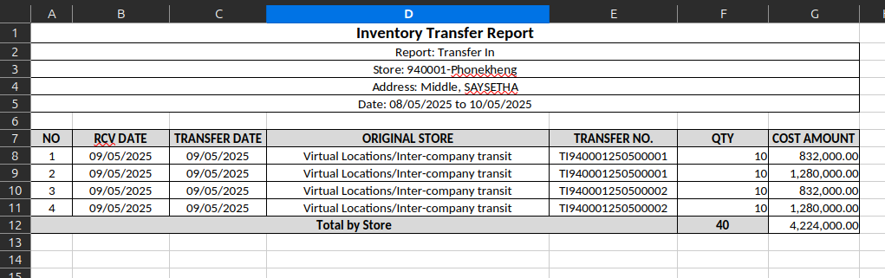**Excel for the same Transfer In :**

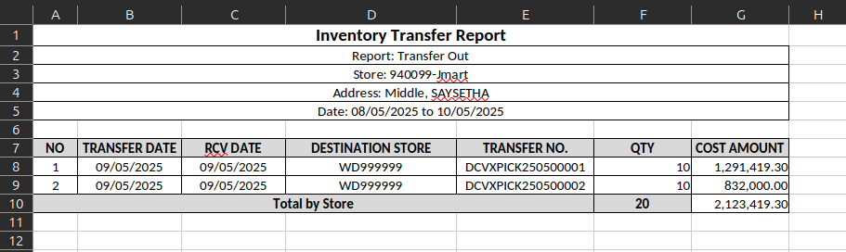**Excel for Transfer Out :**